AI Assisted Coding

Lab 11.2 – Data Structures with AI

Course: AI Assisted Coding
2303A51221
T.SAI SATHWIK
Program: B.Tech CSE
Year/Sem: III/II
Academic Year: 2025-2026
Objective:
To use AI-assisted coding to design and implement fundamental data structures in Python including Stack, Queue, Linked List, Binary Search Tree, and Hash Table.
Task 1: Stack Implementation
Prompt:
"Using AI-assisted coding, design and implement a Stack data structure in Python with push, pop, peek, and isEmpty operations."
Code:
class Stack:
def __init__(self):
self.stack = []

def push(self, item):
self.stack.append(item)

def pop(self):
if self.isEmpty():
return "Stack is empty"
return self.stack.pop()

def peek(self):
if self.isEmpty():
return "Stack is empty"
return self.stack[-1]

def isEmpty(self):
return len(self.stack) == 0
Explanation:
This program implements Stack using list with LIFO principle.
Output:
Top element: 20
Popped element: 20
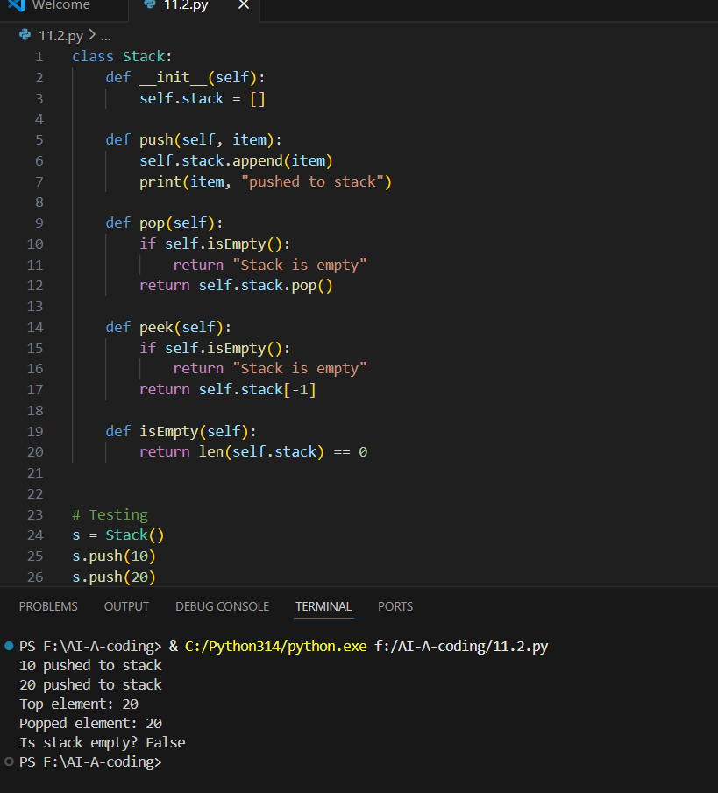
Task 2: Queue Implementation
Prompt:
"Design a Queue using FIFO principle with enqueue, dequeue, front and size operations."
Code:
class Queue:
def __init__(self):
self.queue = []

def enqueue(self, item):
self.queue.append(item)

def dequeue(self):
if self.isEmpty():
return "Queue is empty"
return self.queue.pop(0)

def front(self):
return self.queue[0]

def size(self):
return len(self.queue)

def isEmpty(self):
return len(self.queue) == 0
Explanation:
Queue follows FIFO principle.
Output:
Front element: 5
Dequeued element: 5
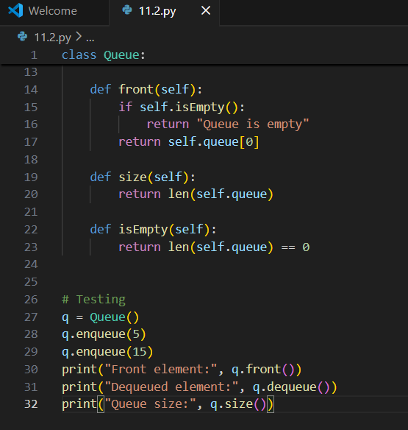
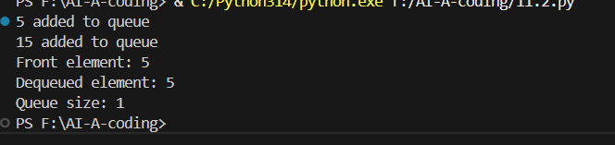
Task 3: Singly Linked List
Prompt:
"Create singly linked list with insertion and traversal."
Code:
class Node:
def __init__(self,data):
self.data=data
self.next=None

class LinkedList:
def __init__(self):
self.head=None

def insert(self,data):
new_node=Node(data)
if self.head is None:
self.head=new_node
else:
temp=self.head
while temp.next:
temp=temp.next
temp.next=new_node

def display(self):
temp=self.head
while temp:
print(temp.data,end="->")
temp=temp.next
Explanation:
Linked list connects nodes using pointers.
Output:
10->20->30->None
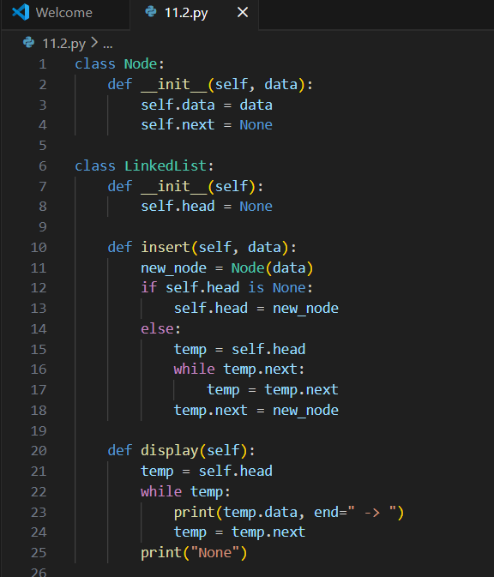
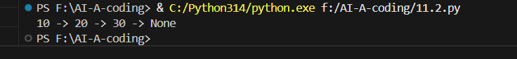
Task 4: Binary Search Tree
Prompt:
"Implement BST with insertion and inorder traversal."
Code:
class Node:
def __init__(self,key):
self.left=None
self.right=None
self.val=key

def insert(root,key):
if root is None:
return Node(key)
if key<root.val:
root.left=insert(root.left,key)
else:
root.right=insert(root.right,key)
return root

def inorder(root):
if root:
inorder(root.left)
print(root.val,end=" ")
inorder(root.right)
Explanation:
BST stores values in sorted order.
Output:
20 30 40 50 60 70 80
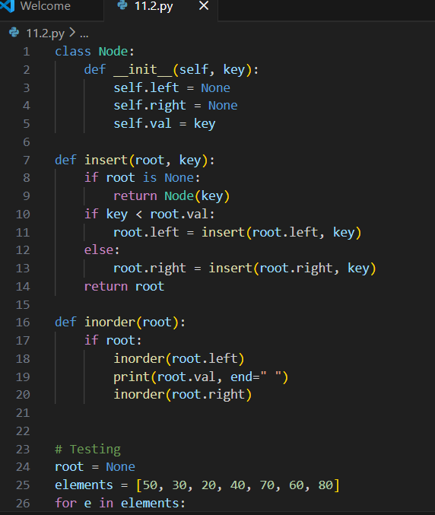
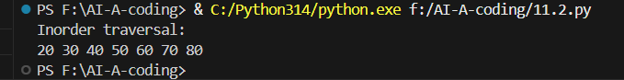
Task 5: Hash Table
Prompt:
Create Hash Table with collision handling using chaining.
Code:
class HashTable:
def __init__(self,size):
self.size=size
self.table=[[] for _ in range(size)]

def hashFunction(self,key):
return key%self.size

def insert(self,key,value):
index=self.hashFunction(key)
self.table[index].append((key,value))

def search(self,key):
index=self.hashFunction(key)
for pair in self.table[index]:
if pair[0]==key:
return pair[1]
return "Not Found"

def delete(self,key):
index=self.hashFunction(key)
for pair in self.table[index]:
if pair[0]==key:
self.table[index].remove(pair)
return "Deleted"
return "Not Found"
Explanation:
Hash table stores key-value pairs using hashing with chaining.
Output:
Apple
Deleted
Not Found

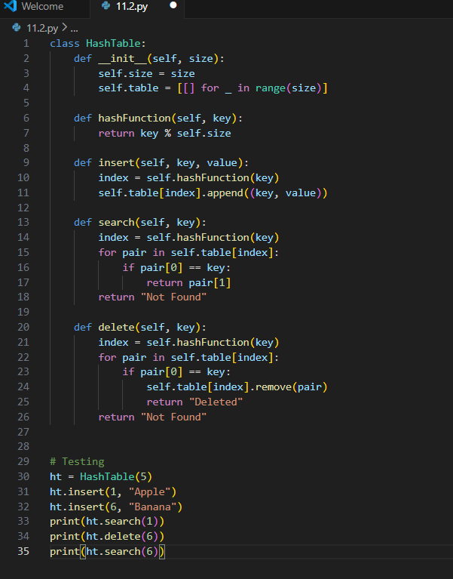
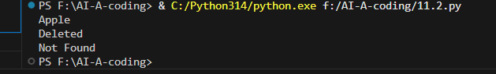
Conclusion:
AI-assisted coding simplifies implementation of data structures and improves understanding of algorithms and logic.

